**THEOBROMA-Bakery website (WP PROJECT)**

**Frameworks used:**

**Front End:**

* HTML
* CSS
* Bootstrap
* Javacript
* jQuery
* EJS

**Back End:**

* Node js (server side scripting)
* MySql (Databse)

**IDEA:**

Theobroma is a bakery website, where a user can order a bakery products.

There is a sign up page where u can create a user account.

The login enables the user to make an order for his/her desired product.

The session tracking is done using express-session.

The order page dynamically displays the table of the products which are added to the cart by the user.

Once the placed order is placed for it gets removed from the order page .

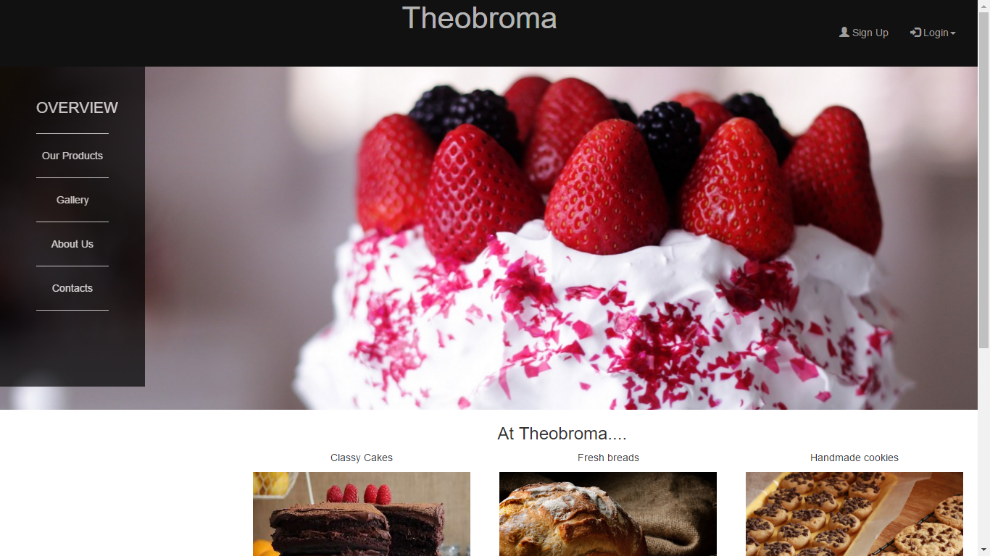

HOME SCREEN

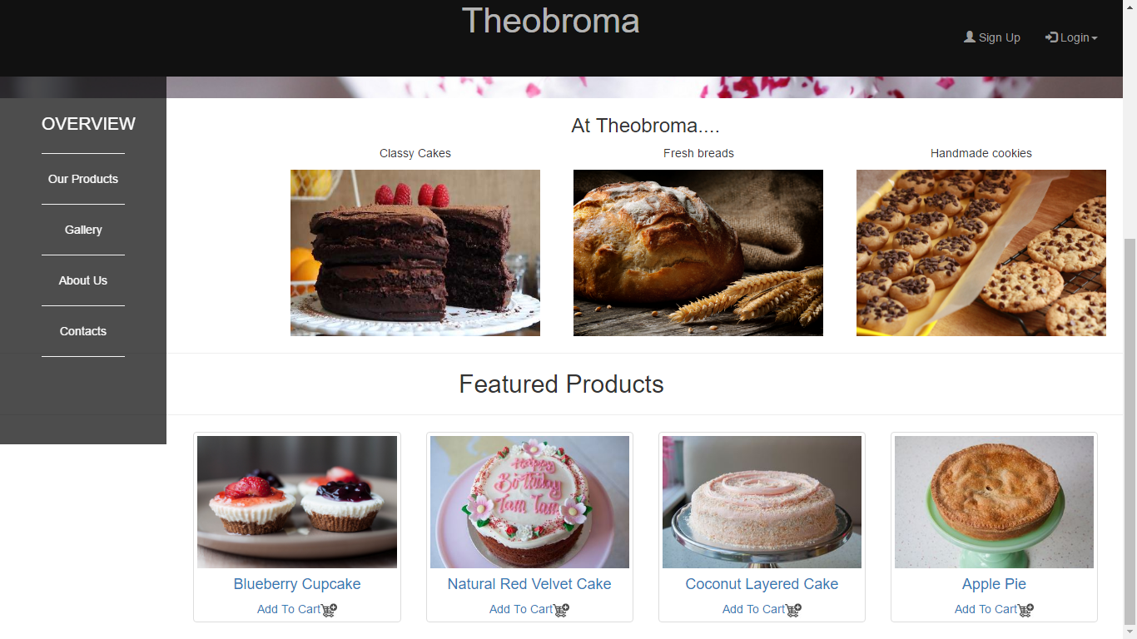

HOME SCREEN

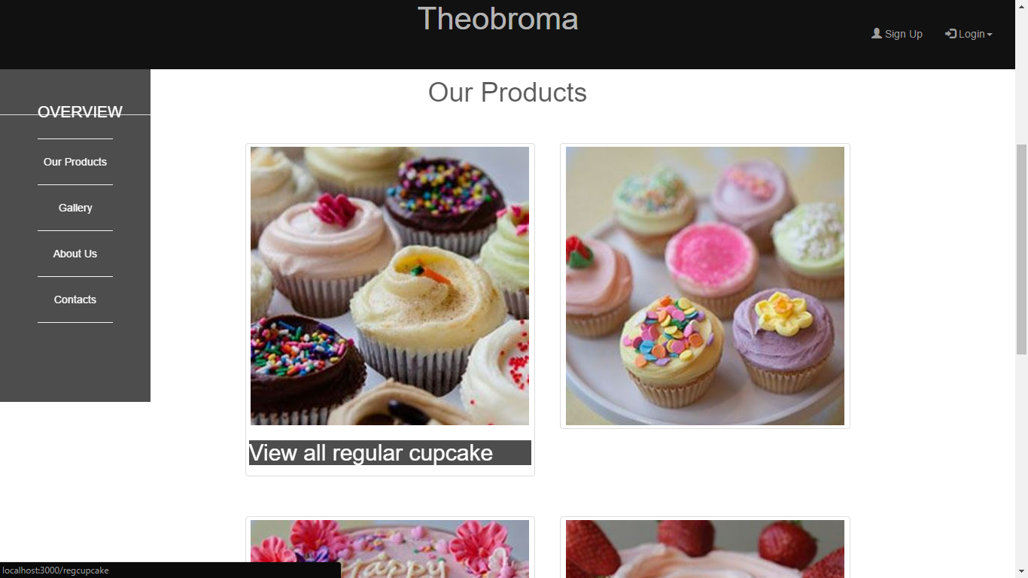

PRODUCTS PAGE: Hover event used to show the category name

VARIOUS CATEGORY PAGES:

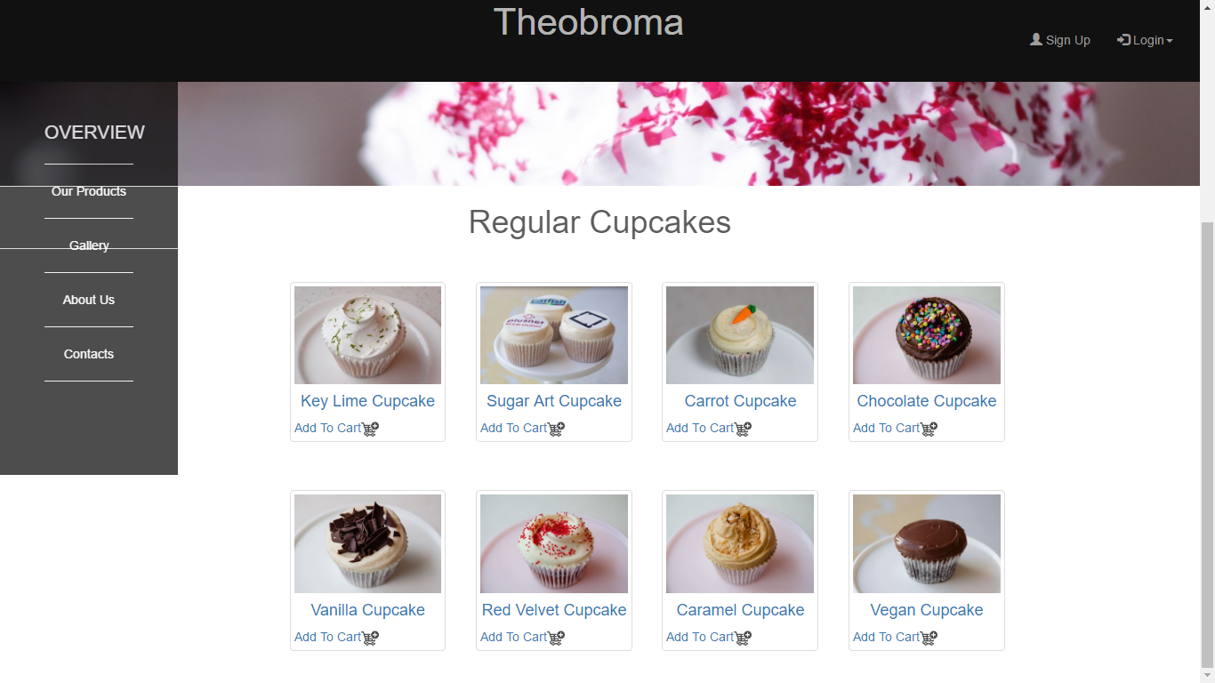

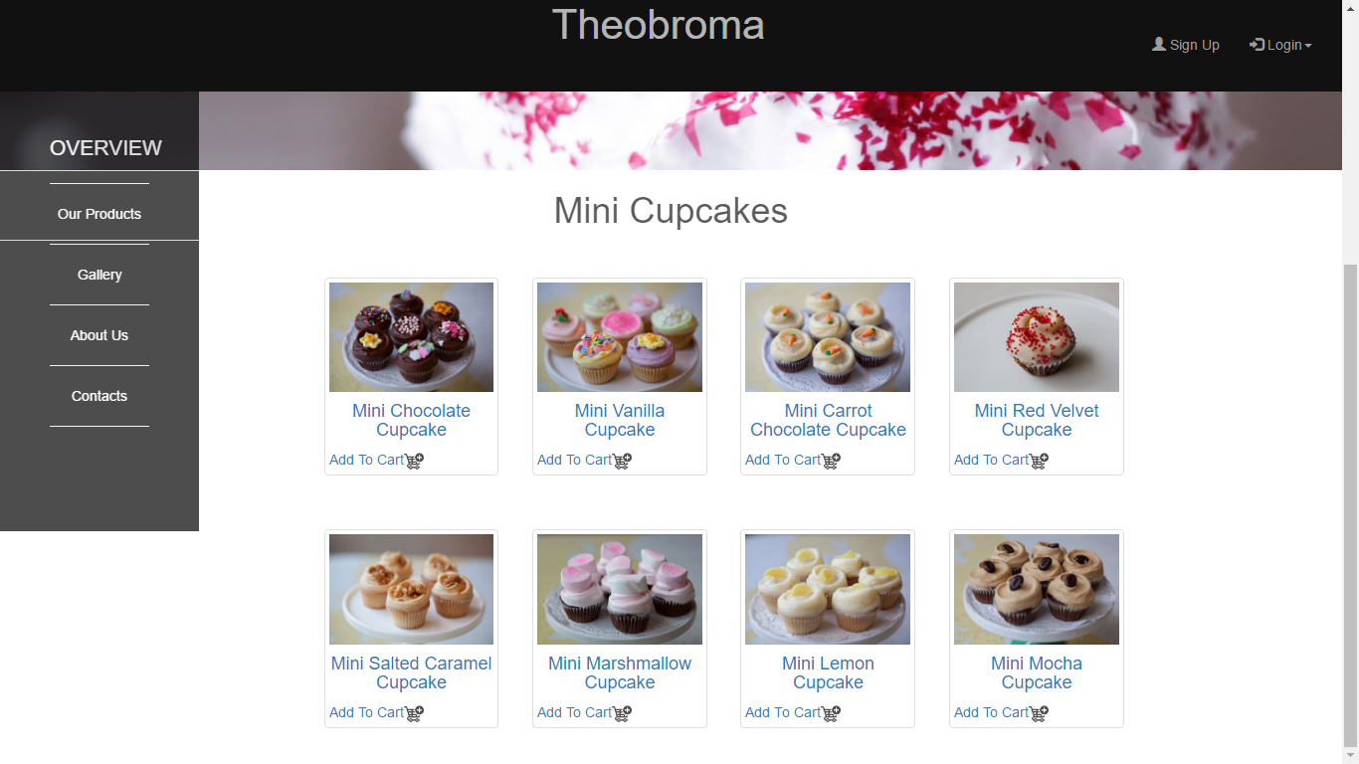

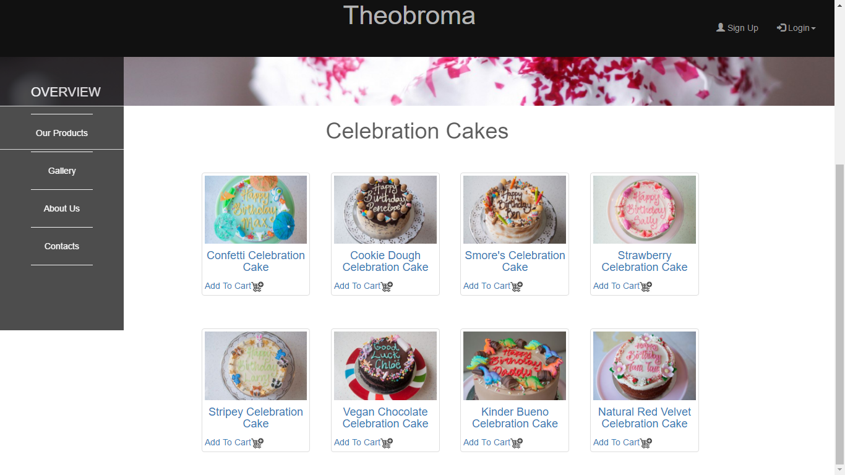

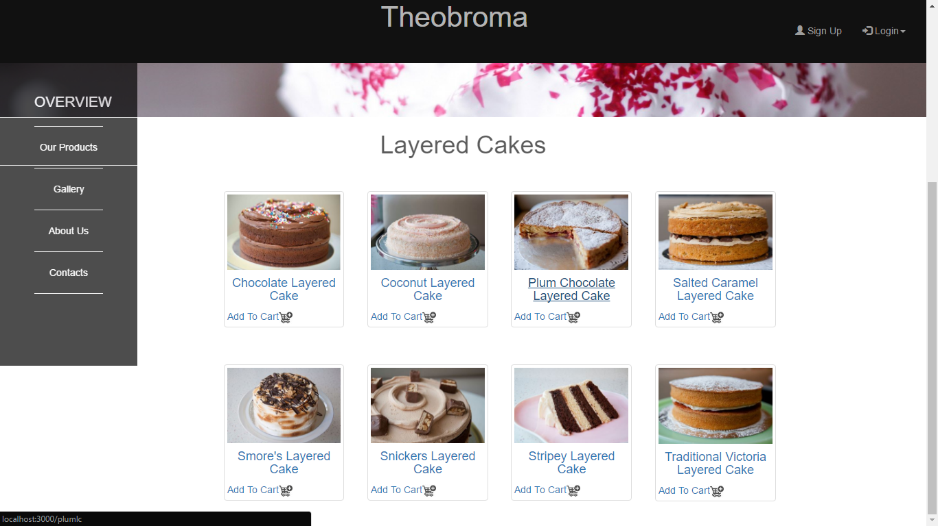

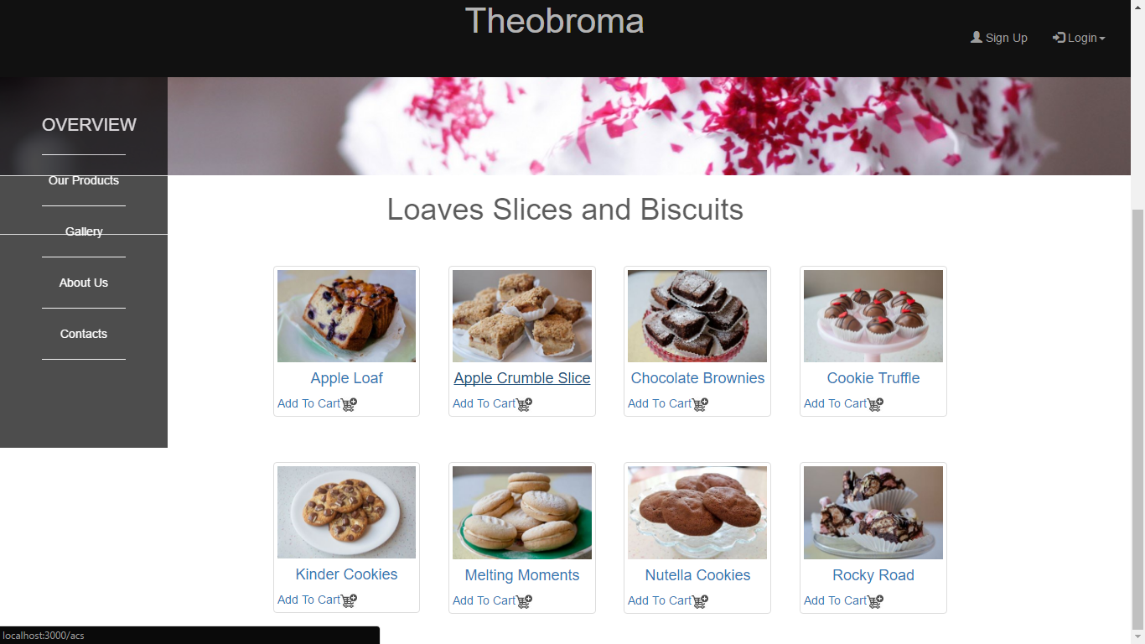

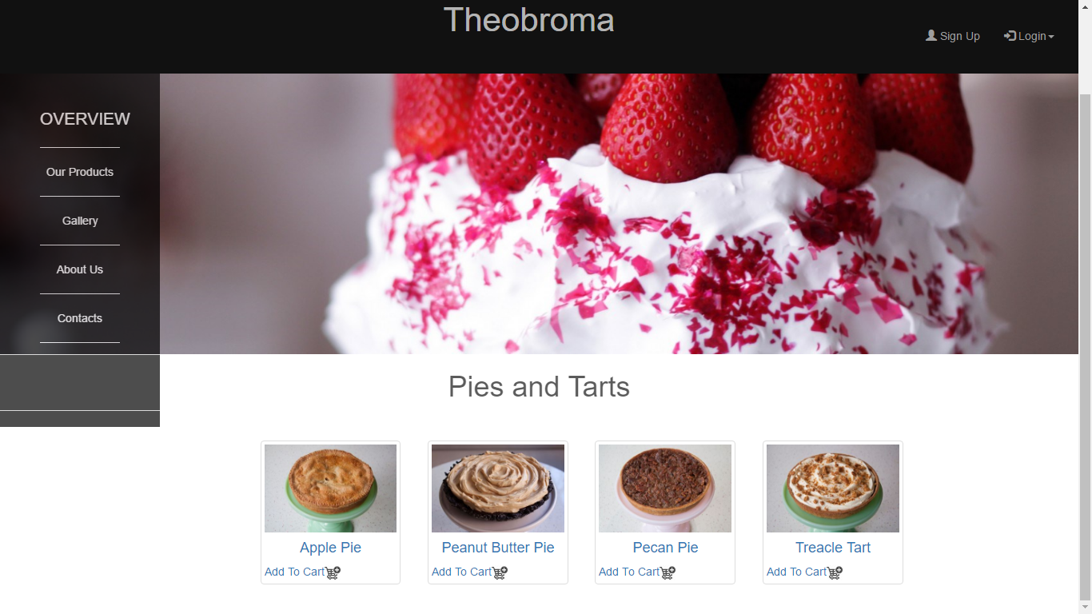

SIGN UP PAGE:

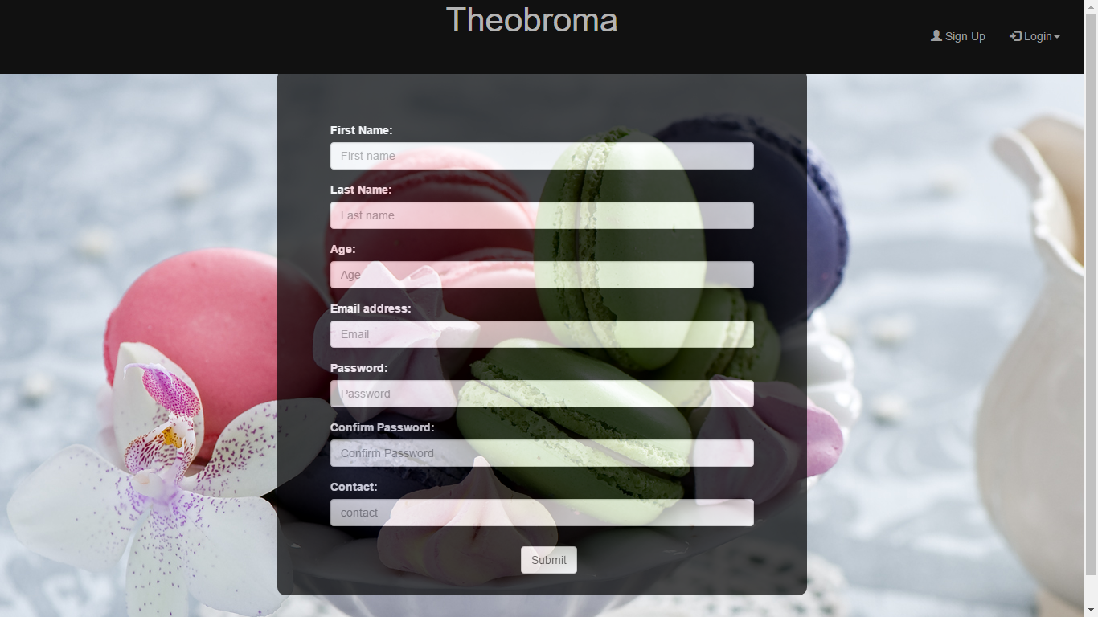

THE LOGIN TAB

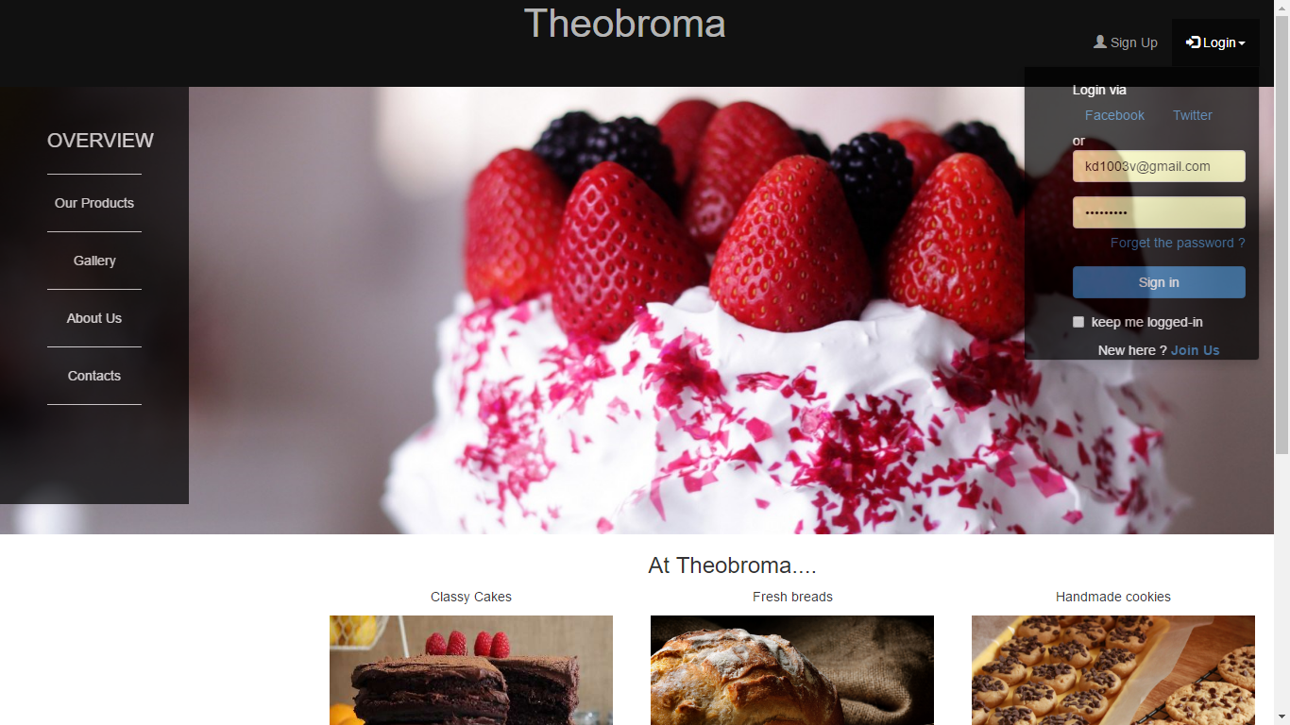

USER SESSION :

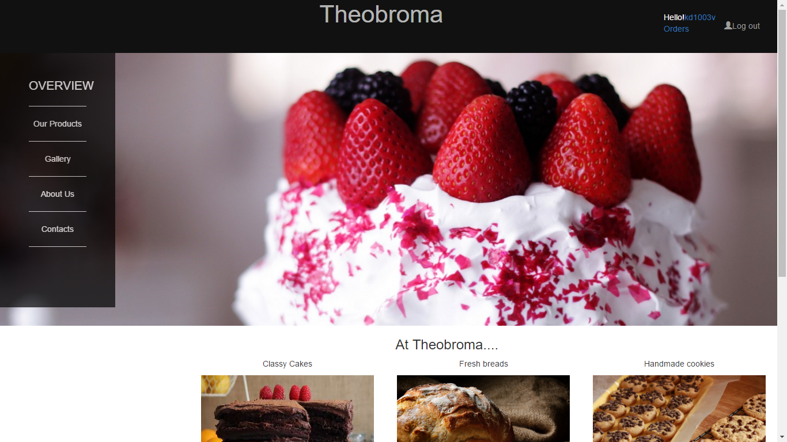

THE ORDER PAGE using MVC

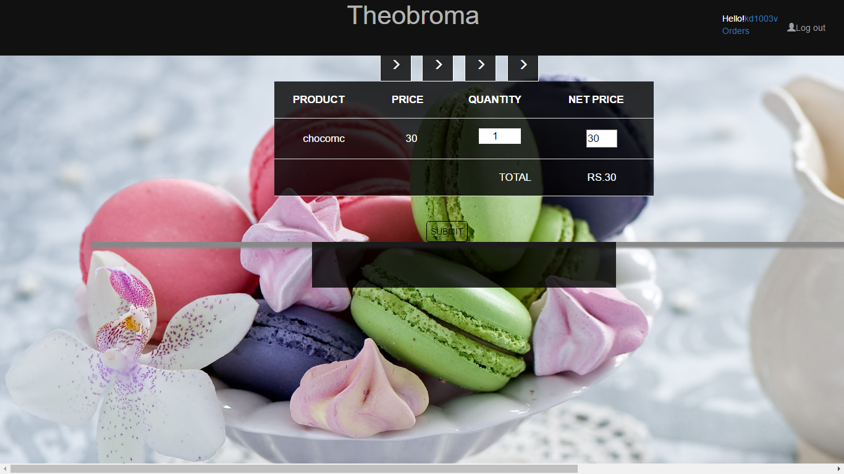

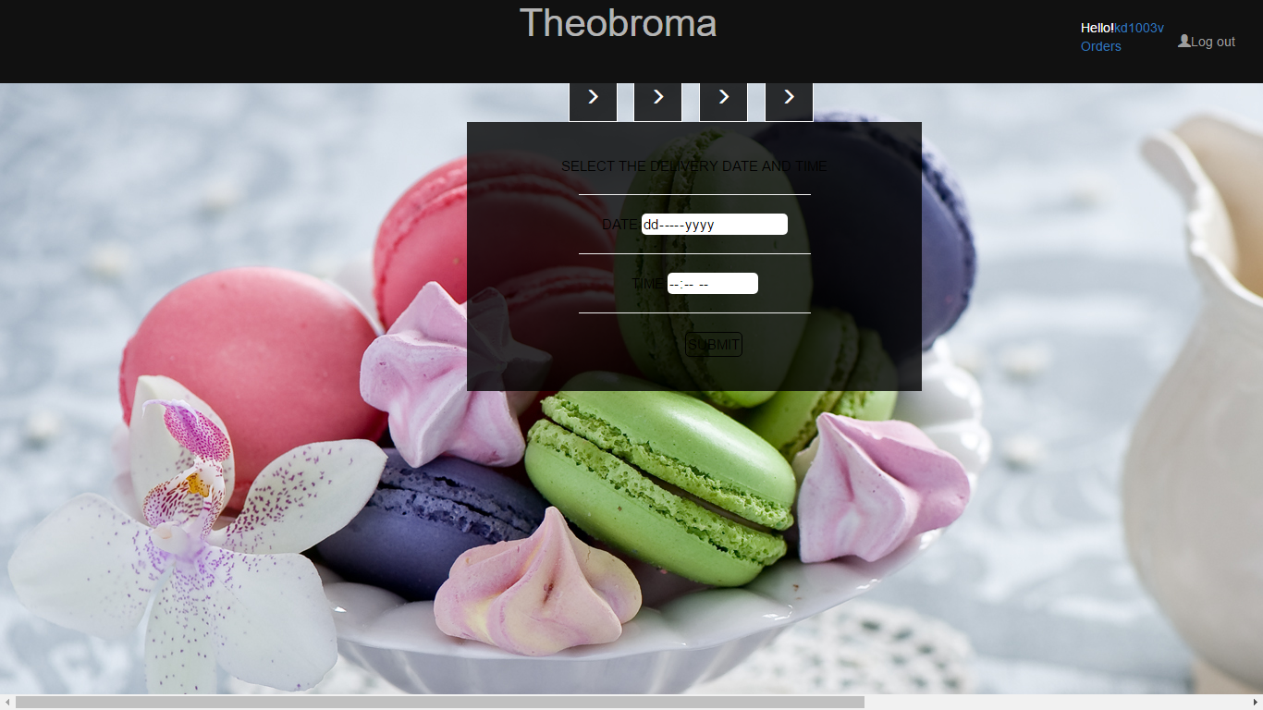

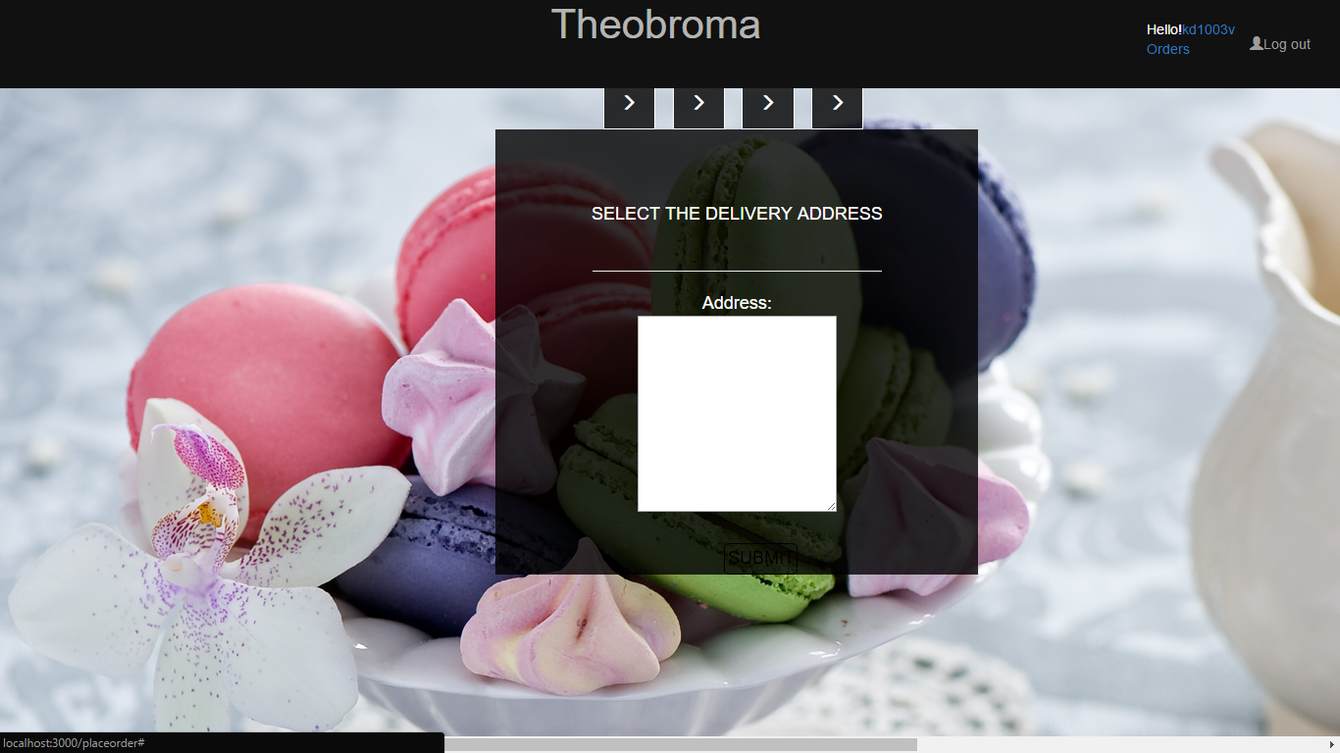

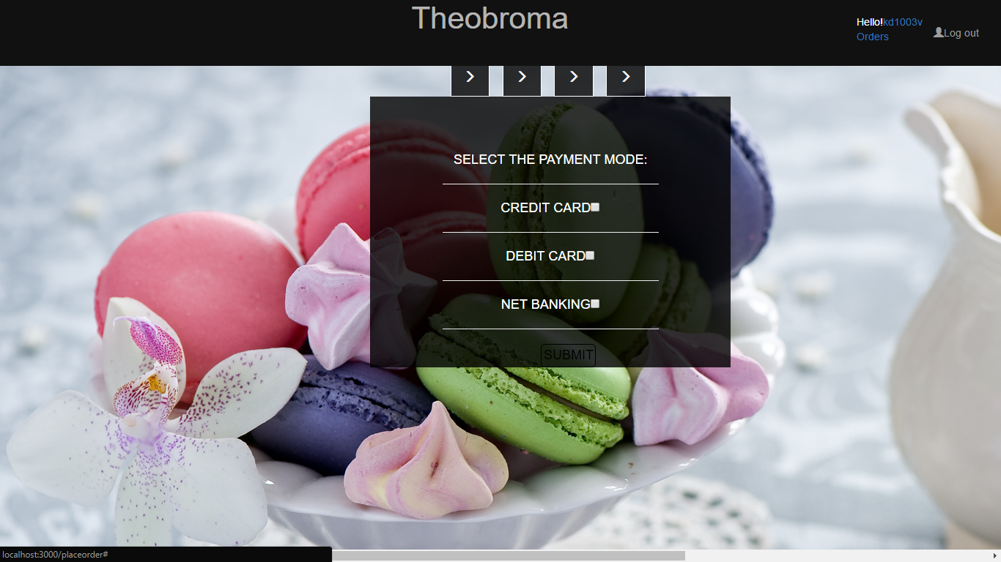

THE DATABASE:

Consisting of three tables

* Customer: contains the information about the various customers
* Products: containing the list and details of all the products
* Order list: Contains transaction information and logs

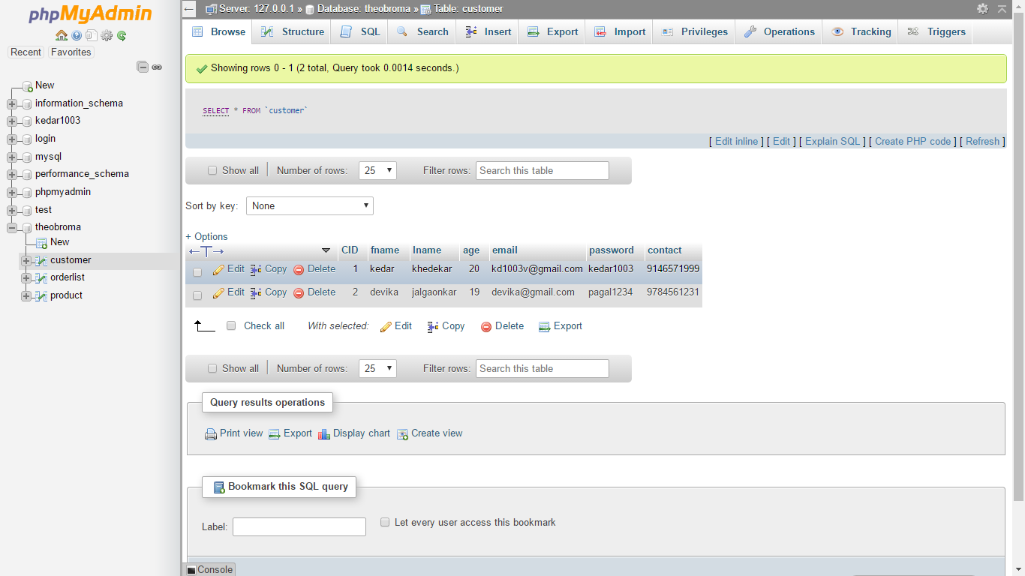

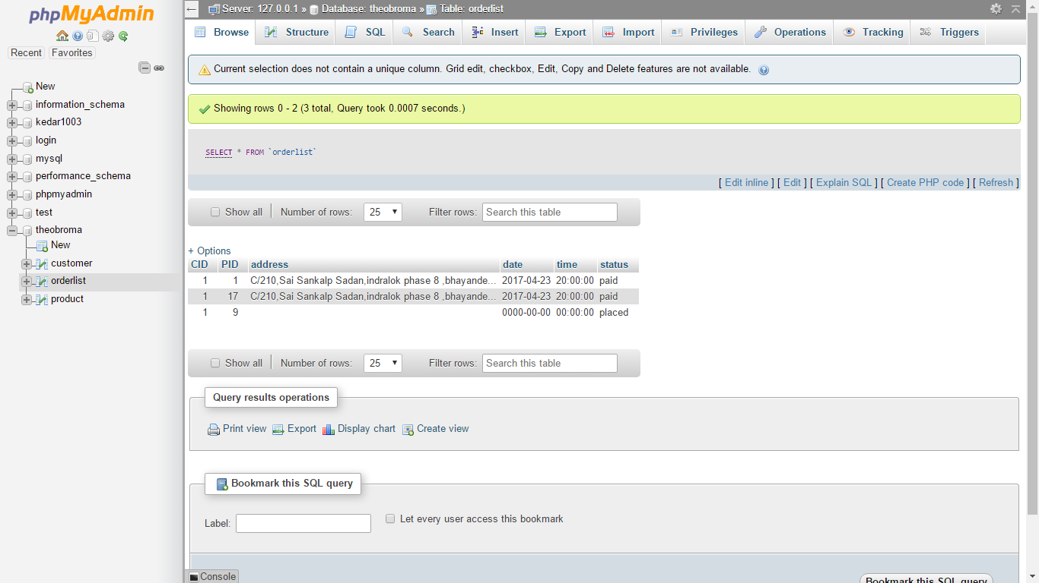

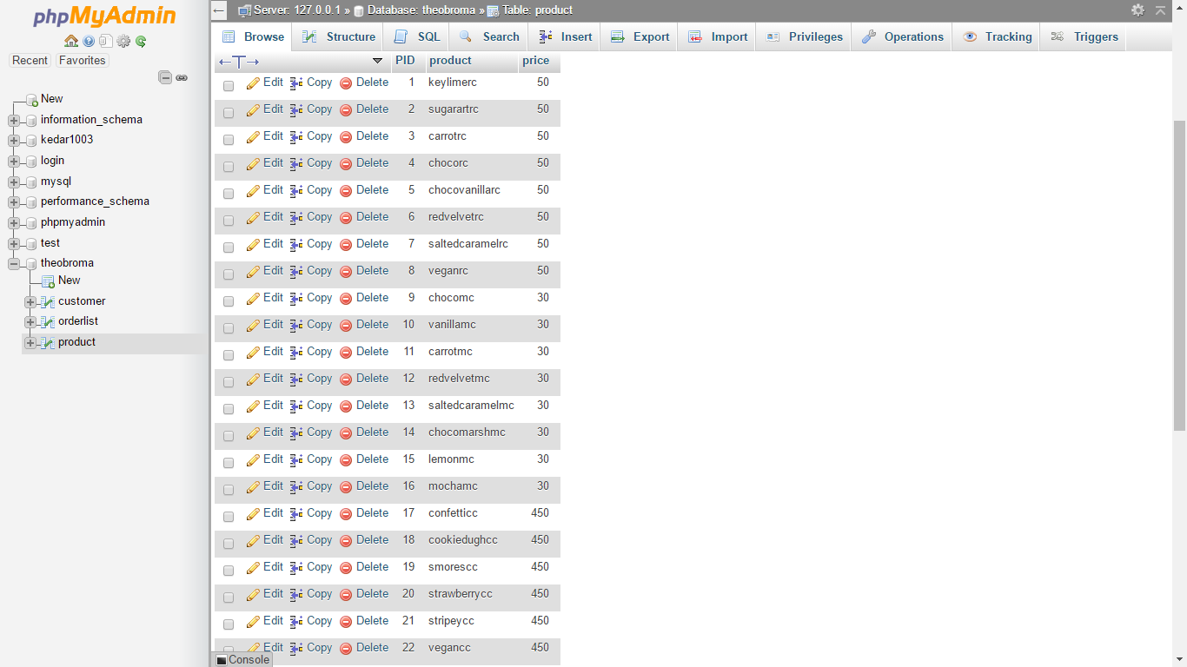

**Group members:**

33-Ninad jagdale

35-Devika Jalgaonkar

36-Aastha Joshi

37-KEDAR KHEDEKAR